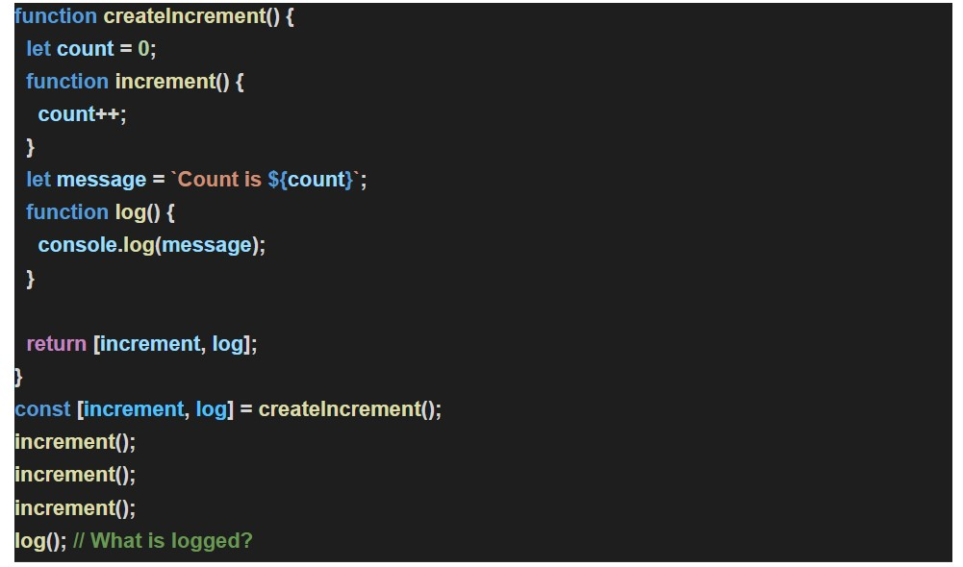

The O/P of the program is :

Count is 0

Reason for the Output :

During the execution of the program when this line is encountered

**const[increment , log] = createIncrement();**

what happens is that when this line is encountered the message string is created then here the message string is created as  **Count is 0**

Later when ,

**increment()** - is encountered 3 times the count gets incremented by 1 every time but the thing to note here is that , when upon calling this function , it didn't alter the message string that was created earlier, so the message string remained as **Count is 0** so when **log();** was encountered finally, it printed the message **Count is 0** as it was not altered by the 3 consecutive increments